LAPORAN

WORKSHOP SISTEM INFORMASI
WEB SERVER (TIF330805)

SEMESTER 3



ACARA 8

NAMA:
MUHAMMAD AFIF RAMDHANI

NIM:
E41250223

PROGRAM STUDI DILUAR KAMPUS UTAMA (PSDKU)
TEKNIK INFORMATIKA KAB. NGANJUK
JURUSAN TEKNOLOGI INFORMASI
POLITEKNIK NEGERI JEMBER
TAHUN 2026

BAB 1 PENDAHULUAN

1.1 Judul Tugas

1.2 Tujuan Tugas

1.3 Dasar Teori
. Middleware merupakan komponen yang digunakan untuk melakukan pemeriksaan sebelum request diteruskan ke controller. Pada aplikasi SI Akademik, middleware digunakan untuk memeriksa status login pengguna sebelum mengakses halaman yang dilindungi. Jika pengguna belum login, maka pengguna diarahkan ke halaman login.
.

BAB 2 PEMBAHASAN

2.1 Alat dan Bahan
- Laptop/PC
- Web Browser
- Visual Studio Code
- XAMPP/Laragon
- PHP
- HTML, CSS, Bootstrap
- Modul Praktikum

2.2 Langkah-Langkah dan Hasil
- Buat file app/Core/Database.php
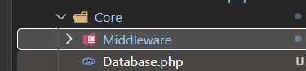

Setelah itu masukan kode program
<?php

namespace App\Core;

use PDO;
use PDOException;

class Database
{
private static ?PDO $instance = null;

// Constructor private → tidak boleh ada yang bikin object ini pakai "new Database()"
private function __construct()
{
}

public static function getInstance(): PDO
{
if (self::$instance === null) {
$host = 'localhost';
$dbname = 'si_akademik';
$username = 'root';
$password = '';

try {
self::$instance = new PDO(
"mysql:host=$host;dbname=$dbname;charset=utf8mb4",
$username,
$password
);
self::$instance->setAttribute(PDO::ATTR_ERRMODE, PDO::ERRMODE_EXCEPTION);
} catch (PDOException $e) {
die("Koneksi database gagal: " . $e->getMessage());
}
}

return self::$instance;
}
}

Bedanya dengan config/database.php yang lama: file lama membuat variabel global $pdo yang harus di-require dan diambil lewat global $pdo di tiap Model. Cara baru ini, Model cukup panggil Database::getInstance() kapan saja, tanpa perlu global atau require berulang namespace PHP (use App\Core\Database;) yang menangani importnya.

- Siapkan Skema Database Tabel prodi dan mata_kuliah
Buka Xampp dan nyalakan MySql dan Apache
Buka database si_akademik, setelah itu karena prodi_id belum ada, jalankan dulu (pastikan tab/database aktifnya si_akademik, tabel manapun tidak masalah asal query-nya eksplisit sebut mahasiswa):
ALTER TABLE mahasiswa ADD COLUMN prodi_id INT NULL;
ALTER TABLE mahasiswa ADD COLUMN email VARCHAR(100) NULL;

Baru setelah itu, jalankan ulang query migrasi:
UPDATE mahasiswa m
JOIN prodi p ON p.nama_prodi = m.prodi
SET m.prodi_id = p.id;

Setelah itu tambahkan Foreign Key
ALTER TABLE mahasiswa
ADD CONSTRAINT fk_mahasiswa_prodi
FOREIGN KEY (prodi_id)
REFERENCES prodi(id)
ON UPDATE CASCADE
ON DELETE SET NULL;

Desaignernya
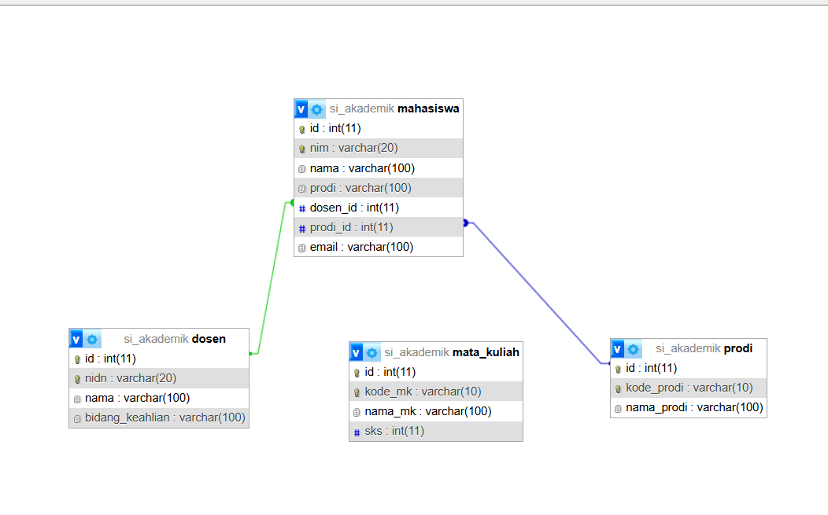

- Update app/Controllers/MahasiswaController.php
<?php

namespace App\Controllers;

require_once __DIR__ . '/../Models/Mahasiswa.php';
require_once __DIR__ . '/../Models/Prodi.php';

use App\Models\Mahasiswa;
use App\Models\Prodi;

class MahasiswaController
{
public function index()
{
$model = new Mahasiswa();
$mahasiswa = $model->all();

require __DIR__ . '/../Views/Mahasiswa/index.php';
}

public function create()
{
$prodiModel = new Prodi();
$prodi = $prodiModel->all();

require __DIR__ . '/../Views/Mahasiswa/create.php';
}

public function store()
{
$model = new Mahasiswa();
$model->create([
'nim' => $_POST['nim'],
'nama' => $_POST['nama'],
'prodi_id' => $_POST['prodi_id'],
'email' => $_POST['email'],
]);

header('Location: /si-akademik/public/mahasiswa');
exit;
}

public function edit($id)
{
$model = new Mahasiswa();
$mahasiswa = $model->find((int) $id);

if (!$mahasiswa) {
echo "Data mahasiswa tidak ditemukan";
return;
}

$prodiModel = new Prodi();
$prodi = $prodiModel->all();

require __DIR__ . '/../Views/Mahasiswa/edit.php';
}

public function update($id)
{
$model = new Mahasiswa();
$model->update((int) $id, [
'nim' => $_POST['nim'],
'nama' => $_POST['nama'],
'prodi_id' => $_POST['prodi_id'],
'email' => $_POST['email'],
]);

header('Location: /si-akademik/public/mahasiswa');
exit;
}

public function destroy($id)
{
$model = new Mahasiswa();
$model->delete((int) $id);

header('Location: /si-akademik/public/mahasiswa');
exit;
}
}

- Buat View Baru: app/Views/Mahasiswa/create.php
Masukkan kode program
<!DOCTYPE html>
<html lang="id">
<head>
<meta charset="UTF-8">
<meta name="viewport" content="width=device-width, initial-scale=1.0">
<title>Tambah Mahasiswa</title>
<link href="https://cdn.jsdelivr.net/npm/bootstrap@5.3.3/dist/css/bootstrap.min.css" rel="stylesheet">
</head>
<body>

<div class="container mt-5">

<h2 class="mb-4">Tambah Mahasiswa</h2>

<a href="/si-akademik/public/mahasiswa" class="btn btn-secondary btn-sm mb-3">
&laquo; Kembali
</a>

<form method="POST" action="/si-akademik/public/mahasiswa/store">

<div class="mb-3">
<label class="form-label">NIM</label>
<input type="text" name="nim" class="form-control" required>
</div>

<div class="mb-3">
<label class="form-label">Nama</label>
<input type="text" name="nama" class="form-control" required>
</div>

<div class="mb-3">
<label class="form-label">Program Studi</label>
<select name="prodi_id" class="form-select" required>
<option value="" disabled selected>-- Pilih Prodi --</option>
<?php foreach ($prodi as $p): ?>
<option value="<?= $p['id'] ?>">
<?= htmlspecialchars($p['nama_prodi']) ?>
</option>
<?php endforeach; ?>
</select>
</div>

<div class="mb-3">
<label class="form-label">Email</label>
<input type="email" name="email" class="form-control" required>
</div>

<button type="submit" class="btn btn-dark">Simpan</button>

</form>

</div>

</body>
</html>

- Buat View Baru: app/Views/Mahasiswa/edit.php
Masukkan kode program
<!DOCTYPE html>
<html lang="id">
<head>
<meta charset="UTF-8">
<meta name="viewport" content="width=device-width, initial-scale=1.0">
<title>Edit Mahasiswa</title>
<link href="https://cdn.jsdelivr.net/npm/bootstrap@5.3.3/dist/css/bootstrap.min.css" rel="stylesheet">
</head>
<body>

<div class="container mt-5">

<h2 class="mb-4">Edit Mahasiswa</h2>

<a href="/si-akademik/public/mahasiswa" class="btn btn-secondary btn-sm mb-3">
&laquo; Kembali
</a>

<form method="POST" action="/si-akademik/public/mahasiswa/<?= $mahasiswa['id'] ?>/update">

<div class="mb-3">
<label class="form-label">NIM</label>
<input type="text" name="nim" class="form-control"
value="<?= htmlspecialchars($mahasiswa['nim']) ?>" required>
</div>

<div class="mb-3">
<label class="form-label">Nama</label>
<input type="text" name="nama" class="form-control"
value="<?= htmlspecialchars($mahasiswa['nama']) ?>" required>
</div>

<div class="mb-3">
<label class="form-label">Program Studi</label>
<select name="prodi_id" class="form-select" required>
<?php foreach ($prodi as $p): ?>
<option value="<?= $p['id'] ?>"
<?= ((int) $p['id'] === (int) $mahasiswa['prodi_id']) ? 'selected' : '' ?>>
<?= htmlspecialchars($p['nama_prodi']) ?>
</option>
<?php endforeach; ?>
</select>
</div>

<div class="mb-3">
<label class="form-label">Email</label>
<input type="email" name="email" class="form-control"
value="<?= htmlspecialchars($mahasiswa['email'] ?? '') ?>" required>
</div>

<button type="submit" class="btn btn-dark">Update</button>

</form>

</div>

</body>
</html>

- Update app/Views/Mahasiswa/index.php
Masukkan kode program baru
<!DOCTYPE html>
<html lang="id">
<head>
<meta charset="UTF-8">
<meta name="viewport" content="width=device-width, initial-scale=1.0">
<title>Data Mahasiswa</title>
<link href="https://cdn.jsdelivr.net/npm/bootstrap@5.3.3/dist/css/bootstrap.min.css" rel="stylesheet">
</head>
<body>

<div class="container mt-5">

<div class="d-flex justify-content-between align-items-center mb-4">
<h2 class="mb-0">Data Mahasiswa</h2>
<a href="/si-akademik/public/mahasiswa/create" class="btn btn-dark">
+ Tambah Mahasiswa
</a>
</div>

<table class="table table-bordered table-striped">
<thead class="table-dark">
<tr>
<th>No</th>
<th>NIM</th>
<th>Nama</th>
<th>Program Studi</th>
<th>Email</th>
<th>Aksi</th>
</tr>
</thead>
<tbody>
<?php if (!empty($mahasiswa)): ?>
<?php foreach ($mahasiswa as $index => $mhs): ?>
<tr>
<td><?= $index + 1 ?></td>
<td><?= htmlspecialchars($mhs['nim']) ?></td>
<td><?= htmlspecialchars($mhs['nama']) ?></td>
<td><?= htmlspecialchars($mhs['nama_prodi'] ?? '-') ?></td>
<td><?= htmlspecialchars($mhs['email'] ?? '-') ?></td>
<td>
<a href="/si-akademik/public/mahasiswa/<?= $mhs['id'] ?>/edit"
class="btn btn-sm btn-warning">
Edit
</a>

<form method="POST"
action="/si-akademik/public/mahasiswa/<?= $mhs['id'] ?>/delete"
class="d-inline"
onsubmit="return confirm('Yakin ingin menghapus data ini?');">
<button type="submit" class="btn btn-sm btn-danger">
Hapus
</button>
</form>
</td>
</tr>
<?php endforeach; ?>
<?php else: ?>
<tr>
<td colspan="6" class="text-center">Belum ada data mahasiswa.</td>
</tr>
<?php endif; ?>
</tbody>
</table>

</div>

</body>
</html>

- Update Models/Mahasiswa.php
Masukkan kode program terbaru
<?php

namespace App\Models;

use App\Core\Database;
use PDO;

class Mahasiswa
{
private PDO $pdo;

public function __construct()
{
$this->pdo = Database::getInstance();
}

public function all(): array
{
$sql = "SELECT mahasiswa.*, prodi.nama_prodi
FROM mahasiswa
LEFT JOIN prodi ON mahasiswa.prodi_id = prodi.id
ORDER BY mahasiswa.nama ASC";

$stmt = $this->pdo->prepare($sql);
$stmt->execute();

return $stmt->fetchAll(PDO::FETCH_ASSOC);
}

public function find(int $id): array|false
{
$sql = "SELECT mahasiswa.*, prodi.nama_prodi
FROM mahasiswa
LEFT JOIN prodi ON mahasiswa.prodi_id = prodi.id
WHERE mahasiswa.id = :id";

$stmt = $this->pdo->prepare($sql);
$stmt->execute(['id' => $id]);

return $stmt->fetch(PDO::FETCH_ASSOC);
}

public function create(array $data): bool
{
$sql = "INSERT INTO mahasiswa (nim, nama, prodi_id, email)
VALUES (:nim, :nama, :prodi_id, :email)";

$stmt = $this->pdo->prepare($sql);

return $stmt->execute([
'nim' => $data['nim'],
'nama' => $data['nama'],
'prodi_id' => $data['prodi_id'],
'email' => $data['email'],
]);
}

public function update(int $id, array $data): bool
{
$sql = "UPDATE mahasiswa
SET nim = :nim, nama = :nama, prodi_id = :prodi_id, email = :email
WHERE id = :id";

$stmt = $this->pdo->prepare($sql);

return $stmt->execute([
'id' => $id,
'nim' => $data['nim'],
'nama' => $data['nama'],
'prodi_id' => $data['prodi_id'],
'email' => $data['email'],
]);
}

public function delete(int $id): bool
{
$stmt = $this->pdo->prepare("DELETE FROM mahasiswa WHERE id = :id");

return $stmt->execute(['id' => $id]);
}
}

- Tambahkan Route CRUD Mahasiswa
Buka routes/web.php. Route /mahasiswa dan /mahasiswa/create yang lama tetap dipakai, tambahkan beberapa route baru. Ganti isi file jadi:
<?php

$routes = [
'GET' => [
'/' => ['HomeController', 'index'],

'/login' => ['AuthController', 'loginForm'],

'/dashboard' => [
'DashboardController',
'index',
'middleware' => ['App\\Core\\Middleware\\AuthMiddleware']
],

'/mahasiswa' => [
'MahasiswaController',
'index',
'middleware' => ['App\\Core\\Middleware\\AuthMiddleware']
],

'/mahasiswa/create' => [
'MahasiswaController',
'create',
'middleware' => ['App\\Core\\Middleware\\AuthMiddleware']
],

'/logout' => ['AuthController', 'logout'],
],

'POST' => [
'/login' => ['AuthController', 'login'],

'/mahasiswa/store' => [
'MahasiswaController',
'store',
'middleware' => ['App\\Core\\Middleware\\AuthMiddleware']
],
],
];

- Update public/index.php
Ganti seluruh isinya jadi:
<?php

require_once __DIR__ . '/../routes/web.php';

require_once __DIR__ . '/../app/Controllers/AuthController.php';
require_once __DIR__ . '/../app/Controllers/DashboardController.php';
require_once __DIR__ . '/../app/Controllers/MahasiswaController.php';
require_once __DIR__ . '/../app/Controllers/HomeController.php';
require_once __DIR__ . '/../app/Core/Database.php';
require_once __DIR__ . '/../app/Core/Middleware/AuthMiddleware.php';

use App\Controllers\AuthController;
use App\Controllers\DashboardController;
use App\Controllers\MahasiswaController;
use App\Controllers\HomeController;
use App\Core\Middleware\AuthMiddleware;

$uri = parse_url($_SERVER['REQUEST_URI'], PHP_URL_PATH);

$base = '/si-akademik/public';

if (str_starts_with($uri, $base)) {
$uri = substr($uri, strlen($base)) ?: '/';
}

$method = $_SERVER['REQUEST_METHOD'];

if (isset($routes[$method][$uri])) {
$route = $routes[$method][$uri];
$params = [];
} else {
$route = null;
$params = [];

$patterns = [
'#^/mahasiswa/(\d+)/edit$#' => ['GET', 'MahasiswaController', 'edit'],
'#^/mahasiswa/(\d+)/update$#' => ['POST', 'MahasiswaController', 'update'],
'#^/mahasiswa/(\d+)/delete$#' => ['POST', 'MahasiswaController', 'destroy'],
];

foreach ($patterns as $pattern => $target) {
[$expectedMethod, $controllerName, $action] = $target;

if ($method === $expectedMethod && preg_match($pattern, $uri, $matches)) {
$route = [
$controllerName,
$action,
'middleware' => ['App\\Core\\Middleware\\AuthMiddleware'],
];
$params = [$matches[1]];
break;
}
}
}

if ($route === null) {
http_response_code(404);
echo "404 - Halaman tidak ditemukan";
exit;
}

$controllerName = $route[0];
$action = $route[1];
$middleware = $route['middleware'] ?? [];

foreach ($middleware as $mw) {
$mwInstance = new $mw();
$mwInstance->handle();
}

$controllerClass = "App\\Controllers\\$controllerName";
$controller = new $controllerClass();

$controller->$action(...$params);

- Ulangi Pola yang Sama untuk Prodi dan Mata Kuliah
Buat app/Models/Prodi.php
Masukkan kode program
<?php

namespace App\Models;

use App\Core\Database;
use PDO;

class Prodi
{
private PDO $pdo;

public function __construct()
{
$this->pdo = Database::getInstance();
}

public function all(): array
{
$stmt = $this->pdo->prepare("SELECT * FROM prodi ORDER BY nama_prodi ASC");
$stmt->execute();

return $stmt->fetchAll(PDO::FETCH_ASSOC);
}

public function find(int $id): array|false
{
$stmt = $this->pdo->prepare("SELECT * FROM prodi WHERE id = :id");
$stmt->execute(['id' => $id]);

return $stmt->fetch(PDO::FETCH_ASSOC);
}

public function create(array $data): bool
{
$stmt = $this->pdo->prepare(
"INSERT INTO prodi (kode_prodi, nama_prodi) VALUES (:kode_prodi, :nama_prodi)"
);

return $stmt->execute([
'kode_prodi' => $data['kode_prodi'],
'nama_prodi' => $data['nama_prodi'],
]);
}

public function update(int $id, array $data): bool
{
$stmt = $this->pdo->prepare(
"UPDATE prodi SET kode_prodi = :kode_prodi, nama_prodi = :nama_prodi WHERE id = :id"
);

return $stmt->execute([
'id' => $id,
'kode_prodi' => $data['kode_prodi'],
'nama_prodi' => $data['nama_prodi'],
]);
}

public function delete(int $id): bool
{
$stmt = $this->pdo->prepare("DELETE FROM prodi WHERE id = :id");

return $stmt->execute(['id' => $id]);
}
}

Buat app/Controllers/ProdiController.php
Masukkan kode program
<?php

namespace App\Controllers;

require_once __DIR__ . '/../Models/Prodi.php';

use App\Models\Prodi;

class ProdiController
{
public function index()
{
$model = new Prodi();
$prodi = $model->all();

require __DIR__ . '/../Views/Prodi/index.php';
}

public function create()
{
require __DIR__ . '/../Views/Prodi/create.php';
}

public function store()
{
$model = new Prodi();
$model->create([
'kode_prodi' => $_POST['kode_prodi'],
'nama_prodi' => $_POST['nama_prodi'],
]);

header('Location: /si-akademik/public/prodi');
exit;
}

public function edit($id)
{
$model = new Prodi();
$prodi = $model->find((int) $id);

if (!$prodi) {
echo "Data prodi tidak ditemukan";
return;
}

require __DIR__ . '/../Views/Prodi/edit.php';
}

public function update($id)
{
$model = new Prodi();
$model->update((int) $id, [
'kode_prodi' => $_POST['kode_prodi'],
'nama_prodi' => $_POST['nama_prodi'],
]);

header('Location: /si-akademik/public/prodi');
exit;
}

public function destroy($id)
{
$model = new Prodi();
$model->delete((int) $id);

header('Location: /si-akademik/public/prodi');
exit;
}
}

Buat app/Views/Prodi/index.php
Masukkan kode program
<!DOCTYPE html>
<html lang="id">
<head>
<meta charset="UTF-8">
<title>Data Prodi</title>
<link href="https://cdn.jsdelivr.net/npm/bootstrap@5.3.3/dist/css/bootstrap.min.css" rel="stylesheet">
</head>
<body>

<div class="container mt-5">

<div class="d-flex justify-content-between align-items-center mb-4">
<h2 class="mb-0">Data Program Studi</h2>
<a href="/si-akademik/public/prodi/create" class="btn btn-dark">+ Tambah Prodi</a>
</div>

<table class="table table-bordered table-striped">
<thead class="table-dark">
<tr>
<th>No</th>
<th>Kode Prodi</th>
<th>Nama Prodi</th>
<th>Aksi</th>
</tr>
</thead>
<tbody>
<?php if (!empty($prodi)): ?>
<?php foreach ($prodi as $index => $p): ?>
<tr>
<td><?= $index + 1 ?></td>
<td><?= htmlspecialchars($p['kode_prodi']) ?></td>
<td><?= htmlspecialchars($p['nama_prodi']) ?></td>
<td>
<a href="/si-akademik/public/prodi/<?= $p['id'] ?>/edit"
class="btn btn-sm btn-warning">Edit</a>

<form method="POST"
action="/si-akademik/public/prodi/<?= $p['id'] ?>/delete"
class="d-inline"
onsubmit="return confirm('Yakin ingin menghapus prodi ini?');">
<button type="submit" class="btn btn-sm btn-danger">Hapus</button>
</form>
</td>
</tr>
<?php endforeach; ?>
<?php else: ?>
<tr><td colspan="4" class="text-center">Belum ada data prodi.</td></tr>
<?php endif; ?>
</tbody>
</table>

</div>

</body>
</html>

Buat app/Views/Prodi/create.php
Masukkan kode program
<!DOCTYPE html>
<html lang="id">
<head>
<meta charset="UTF-8">
<title>Tambah Prodi</title>
<link href="https://cdn.jsdelivr.net/npm/bootstrap@5.3.3/dist/css/bootstrap.min.css" rel="stylesheet">
</head>
<body>

<div class="container mt-5">
<h2 class="mb-4">Tambah Prodi</h2>
<a href="/si-akademik/public/prodi" class="btn btn-secondary btn-sm mb-3">&laquo; Kembali</a>

<form method="POST" action="/si-akademik/public/prodi/store">
<div class="mb-3">
<label class="form-label">Kode Prodi</label>
<input type="text" name="kode_prodi" class="form-control" required>
</div>
<div class="mb-3">
<label class="form-label">Nama Prodi</label>
<input type="text" name="nama_prodi" class="form-control" required>
</div>
<button type="submit" class="btn btn-dark">Simpan</button>
</form>
</div>

</body>
</html>

Buat app/Views/Prodi/edit.php
Masukkan kode program
<!DOCTYPE html>
<html lang="id">
<head>
<meta charset="UTF-8">
<title>Edit Prodi</title>
<link href="https://cdn.jsdelivr.net/npm/bootstrap@5.3.3/dist/css/bootstrap.min.css" rel="stylesheet">
</head>
<body>

<div class="container mt-5">
<h2 class="mb-4">Edit Prodi</h2>
<a href="/si-akademik/public/prodi" class="btn btn-secondary btn-sm mb-3">&laquo; Kembali</a>

<form method="POST" action="/si-akademik/public/prodi/<?= $prodi['id'] ?>/update">
<div class="mb-3">
<label class="form-label">Kode Prodi</label>
<input type="text" name="kode_prodi" class="form-control"
value="<?= htmlspecialchars($prodi['kode_prodi']) ?>" required>
</div>
<div class="mb-3">
<label class="form-label">Nama Prodi</label>
<input type="text" name="nama_prodi" class="form-control"
value="<?= htmlspecialchars($prodi['nama_prodi']) ?>" required>
</div>
<button type="submit" class="btn btn-dark">Update</button>
</form>
</div>

</body>
</html>

Buat app/Models/MataKuliah.php
Masukkan kode program
<?php

namespace App\Models;

use App\Core\Database;
use PDO;

class MataKuliah
{
private PDO $pdo;

public function __construct()
{
$this->pdo = Database::getInstance();
}

public function all(): array
{
$stmt = $this->pdo->prepare("SELECT * FROM mata_kuliah ORDER BY nama_mk ASC");
$stmt->execute();

return $stmt->fetchAll(PDO::FETCH_ASSOC);
}

public function find(int $id): array|false
{
$stmt = $this->pdo->prepare("SELECT * FROM mata_kuliah WHERE id = :id");
$stmt->execute(['id' => $id]);

return $stmt->fetch(PDO::FETCH_ASSOC);
}

public function create(array $data): bool
{
$stmt = $this->pdo->prepare(
"INSERT INTO mata_kuliah (kode_mk, nama_mk, sks) VALUES (:kode_mk, :nama_mk, :sks)"
);

return $stmt->execute([
'kode_mk' => $data['kode_mk'],
'nama_mk' => $data['nama_mk'],
'sks' => $data['sks'],
]);
}

public function update(int $id, array $data): bool
{
$stmt = $this->pdo->prepare(
"UPDATE mata_kuliah SET kode_mk = :kode_mk, nama_mk = :nama_mk, sks = :sks WHERE id = :id"
);

return $stmt->execute([
'id' => $id,
'kode_mk' => $data['kode_mk'],
'nama_mk' => $data['nama_mk'],
'sks' => $data['sks'],
]);
}

public function delete(int $id): bool
{
$stmt = $this->pdo->prepare("DELETE FROM mata_kuliah WHERE id = :id");

return $stmt->execute(['id' => $id]);
}
}

Buat app/Controllers/MataKuliahController.php
Masukkan kode program
<?php

namespace App\Controllers;

require_once __DIR__ . '/../Models/MataKuliah.php';

use App\Models\MataKuliah;

class MataKuliahController
{
public function index()
{
$model = new MataKuliah();
$mataKuliah = $model->all();

require __DIR__ . '/../Views/MataKuliah/index.php';
}

public function create()
{
require __DIR__ . '/../Views/MataKuliah/create.php';
}

public function store()
{
$model = new MataKuliah();
$model->create([
'kode_mk' => $_POST['kode_mk'],
'nama_mk' => $_POST['nama_mk'],
'sks' => $_POST['sks'],
]);

header('Location: /si-akademik/public/mata-kuliah');
exit;
}

public function edit($id)
{
$model = new MataKuliah();
$mataKuliah = $model->find((int) $id);

if (!$mataKuliah) {
echo "Data mata kuliah tidak ditemukan";
return;
}

require __DIR__ . '/../Views/MataKuliah/edit.php';
}

public function update($id)
{
$model = new MataKuliah();
$model->update((int) $id, [
'kode_mk' => $_POST['kode_mk'],
'nama_mk' => $_POST['nama_mk'],
'sks' => $_POST['sks'],
]);

header('Location: /si-akademik/public/mata-kuliah');
exit;
}

public function destroy($id)
{
$model = new MataKuliah();
$model->delete((int) $id);

header('Location: /si-akademik/public/mata-kuliah');
exit;
}
}

Buat app/Views/MataKuliah/index.php
Masukkan kode program
<!DOCTYPE html>
<html lang="id">
<head>
<meta charset="UTF-8">
<title>Data Mata Kuliah</title>
<link href="https://cdn.jsdelivr.net/npm/bootstrap@5.3.3/dist/css/bootstrap.min.css" rel="stylesheet">
</head>
<body>

<div class="container mt-5">

<div class="d-flex justify-content-between align-items-center mb-4">
<h2 class="mb-0">Data Mata Kuliah</h2>
<a href="/si-akademik/public/mata-kuliah/create" class="btn btn-dark">+ Tambah Mata Kuliah</a>
</div>

<table class="table table-bordered table-striped">
<thead class="table-dark">
<tr>
<th>No</th>
<th>Kode MK</th>
<th>Nama Mata Kuliah</th>
<th>SKS</th>
<th>Aksi</th>
</tr>
</thead>
<tbody>
<?php if (!empty($mataKuliah)): ?>
<?php foreach ($mataKuliah as $index => $mk): ?>
<tr>
<td><?= $index + 1 ?></td>
<td><?= htmlspecialchars($mk['kode_mk']) ?></td>
<td><?= htmlspecialchars($mk['nama_mk']) ?></td>
<td><?= htmlspecialchars($mk['sks']) ?></td>
<td>
<a href="/si-akademik/public/mata-kuliah/<?= $mk['id'] ?>/edit"
class="btn btn-sm btn-warning">Edit</a>

<form method="POST"
action="/si-akademik/public/mata-kuliah/<?= $mk['id'] ?>/delete"
class="d-inline"
onsubmit="return confirm('Yakin ingin menghapus mata kuliah ini?');">
<button type="submit" class="btn btn-sm btn-danger">Hapus</button>
</form>
</td>
</tr>
<?php endforeach; ?>
<?php else: ?>
<tr><td colspan="5" class="text-center">Belum ada data mata kuliah.</td></tr>
<?php endif; ?>
</tbody>
</table>

</div>

</body>
</html>

Buat app/Views/MataKuliah/create.php
Masukkan kode program
<!DOCTYPE html>
<html lang="id">
<head>
<meta charset="UTF-8">
<title>Tambah Mata Kuliah</title>
<link href="https://cdn.jsdelivr.net/npm/bootstrap@5.3.3/dist/css/bootstrap.min.css" rel="stylesheet">
</head>
<body>

<div class="container mt-5">
<h2 class="mb-4">Tambah Mata Kuliah</h2>
<a href="/si-akademik/public/mata-kuliah" class="btn btn-secondary btn-sm mb-3">&laquo; Kembali</a>

<form method="POST" action="/si-akademik/public/mata-kuliah/store">
<div class="mb-3">
<label class="form-label">Kode Mata Kuliah</label>
<input type="text" name="kode_mk" class="form-control" required>
</div>
<div class="mb-3">
<label class="form-label">Nama Mata Kuliah</label>
<input type="text" name="nama_mk" class="form-control" required>
</div>
<div class="mb-3">
<label class="form-label">SKS</label>
<input type="number" name="sks" class="form-control" min="1" max="6" required>
</div>
<button type="submit" class="btn btn-dark">Simpan</button>
</form>
</div>

</body>
</html>

Buat app/Views/MataKuliah/edit.php
Masukkan kode program
<!DOCTYPE html>
<html lang="id">
<head>
<meta charset="UTF-8">
<title>Edit Mata Kuliah</title>
<link href="https://cdn.jsdelivr.net/npm/bootstrap@5.3.3/dist/css/bootstrap.min.css" rel="stylesheet">
</head>
<body>

<div class="container mt-5">
<h2 class="mb-4">Edit Mata Kuliah</h2>
<a href="/si-akademik/public/mata-kuliah" class="btn btn-secondary btn-sm mb-3">&laquo; Kembali</a>

<form method="POST" action="/si-akademik/public/mata-kuliah/<?= $mataKuliah['id'] ?>/update">
<div class="mb-3">
<label class="form-label">Kode Mata Kuliah</label>
<input type="text" name="kode_mk" class="form-control"
value="<?= htmlspecialchars($mataKuliah['kode_mk']) ?>" required>
</div>
<div class="mb-3">
<label class="form-label">Nama Mata Kuliah</label>
<input type="text" name="nama_mk" class="form-control"
value="<?= htmlspecialchars($mataKuliah['nama_mk']) ?>" required>
</div>
<div class="mb-3">
<label class="form-label">SKS</label>
<input type="number" name="sks" class="form-control" min="1" max="6"
value="<?= htmlspecialchars($mataKuliah['sks']) ?>" required>
</div>
<button type="submit" class="btn btn-dark">Update</button>
</form>
</div>

</body>
</html>

- Update routes/web.php (Tambah Route Prodi & Mata Kuliah)
Masukkan tambahan kode program
Tambahkan di $routes['GET']:
'/prodi' => [
'ProdiController',
'index',
'middleware' => ['App\\Core\\Middleware\\AuthMiddleware']
],

'/prodi/create' => [
'ProdiController',
'create',
'middleware' => ['App\\Core\\Middleware\\AuthMiddleware']
],

'/mata-kuliah' => [
'MataKuliahController',
'index',
'middleware' => ['App\\Core\\Middleware\\AuthMiddleware']
],

'/mata-kuliah/create' => [
'MataKuliahController',
'create',
'middleware' => ['App\\Core\\Middleware\\AuthMiddleware']
],

Tambahkan di $routes['POST']:
'/prodi/store' => [
'ProdiController',
'store',
'middleware' => ['App\\Core\\Middleware\\AuthMiddleware']
],

'/mata-kuliah/store' => [
'MataKuliahController',
'store',
'middleware' => ['App\\Core\\Middleware\\AuthMiddleware']
],

- Update public/index.php
Tambahkan patter baru
$patterns = [
'#^/mahasiswa/(\d+)/edit$#' => ['GET', 'MahasiswaController', 'edit'],
'#^/mahasiswa/(\d+)/update$#' => ['POST', 'MahasiswaController', 'update'],
'#^/mahasiswa/(\d+)/delete$#' => ['POST', 'MahasiswaController', 'destroy'],

'#^/prodi/(\d+)/edit$#' => ['GET', 'ProdiController', 'edit'],
'#^/prodi/(\d+)/update$#' => ['POST', 'ProdiController', 'update'],
'#^/prodi/(\d+)/delete$#' => ['POST', 'ProdiController', 'destroy'],

'#^/mata-kuliah/(\d+)/edit$#' => ['GET', 'MataKuliahController', 'edit'],
'#^/mata-kuliah/(\d+)/update$#' => ['POST', 'MataKuliahController', 'update'],
'#^/mata-kuliah/(\d+)/delete$#' => ['POST', 'MataKuliahController', 'destroy'],
];

Jangan lupa tambahkan require_once dan use dari controller baru
require_once __DIR__ . '/../app/Controllers/ProdiController.php';
require_once __DIR__ . '/../app/Controllers/MataKuliahController.php';

use App\Controllers\ProdiController;
use App\Controllers\MataKuliahController;

- Pengujian
Login ke aplikasi.
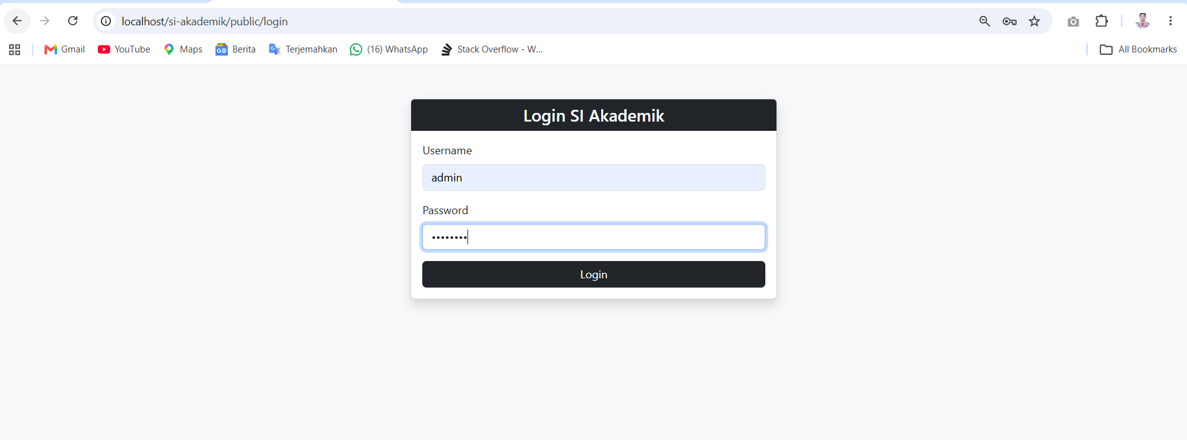
Login menggunakan
Username: admin
Password: admin123

Hasil
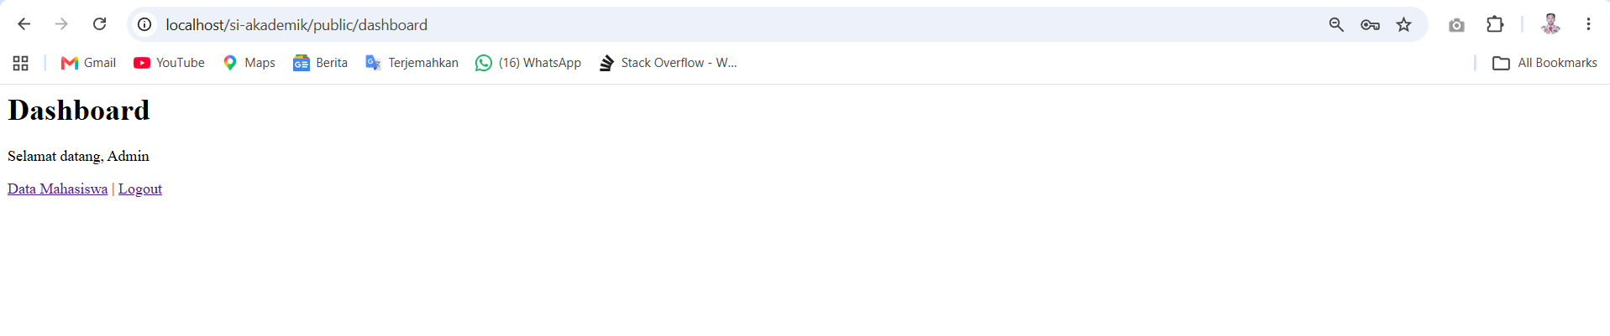

Mahasiswa: tambah, edit, hapus.
Pengujian tambah
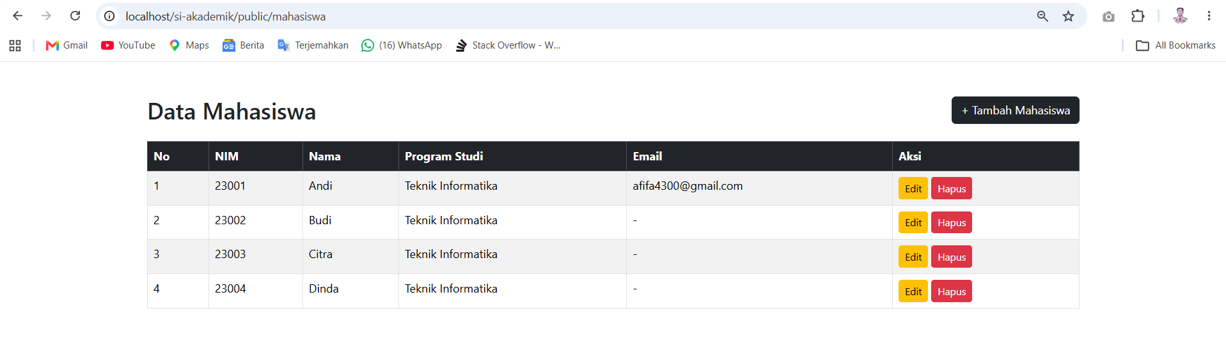

Klik Tambah Mahasiswa
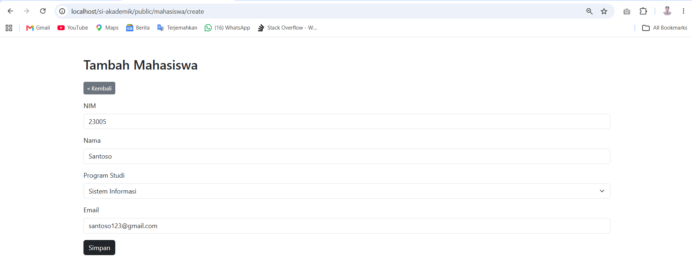
Masukkan data, lalu klik simpan
Hasil
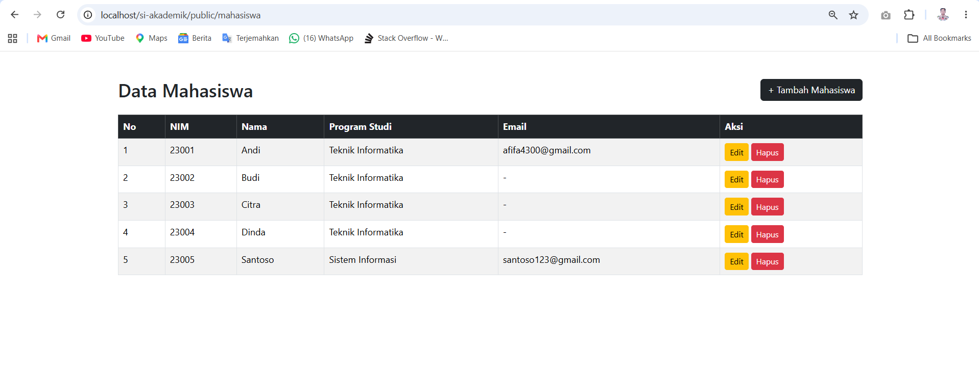

Prodi: tambah, lihat, edit, hapus (dengan konfirmasi JS) — semua jalan.
Mata Kuliah: tambah, lihat, edit, hapus (dengan konfirmasi JS) — semua jalan.
Coba hapus satu prodi yang masih dipakai oleh mahasiswa (ada mahasiswa dengan prodi_id itu) → karena foreign key ON DELETE SET NULL, mahasiswa yang tadinya pakai prodi itu prodi_id-nya otomatis jadi NULL — cek, kolom Program Studi di daftar mahasiswa untuk mahasiswa itu sekarang tampil -.
Logout, coba akses langsung (tanpa login): /mahasiswa, /mahasiswa/create, /mahasiswa/1/edit, /prodi, /mata-kuliah → semua harus dilempar ke /login.
Uji Studi Kasus SQL Injection (opsional tapi bagus untuk laporan): coba ketik ' OR '1'='1 di salah satu input form (misal field NIM saat Tambah Mahasiswa), submit. Karena semua query pakai Prepared Statement, input itu akan disimpan apa adanya sebagai teks (literal ' OR '1'='1), bukan dieksekusi sebagai perintah SQL — buktikan dengan screenshot data yang tersimpan persis sesuai apa yang diketik, bukan membocorkan data lain.

BAB 3 KESIMPULAN

Berdasarkan praktikum Acara 6, dapat disimpulkan bahwa middleware dan autentikasi sederhana berhasil diterapkan pada aplikasi SI Akademik berbasis MVC. AuthMiddleware digunakan untuk memeriksa status login pengguna sebelum mengakses halaman yang dilindungi, sedangkan sistem login menggunakan session untuk menyimpan status dan informasi pengguna. Dengan penerapan tersebut, akses ke halaman Dashboard dan Data Mahasiswa menjadi lebih terkontrol serta struktur aplikasi menjadi lebih terorganisir.

